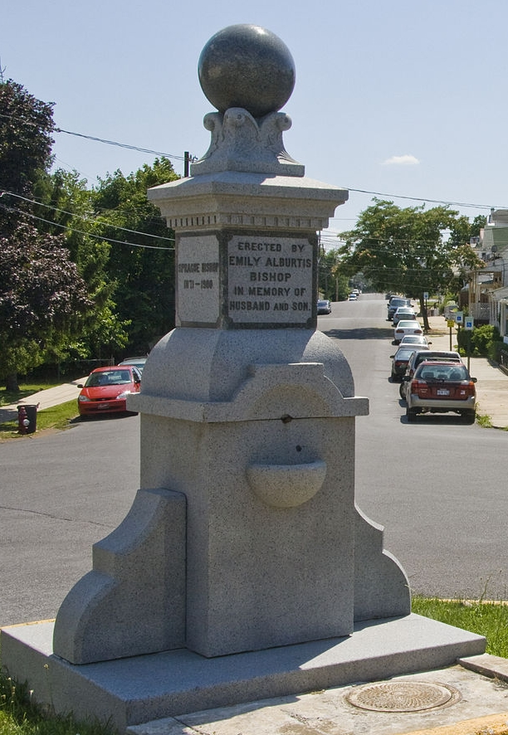
Bishop’s Monument erected by Emily Alburtis Bishop in memory of her husband John and son Sprague.
Facebook pictures and info

John W. Bishop was born March 11, 1843 and died December 12, 1897. He married Emily Showers Alburtis, and their children were Sprague, Kate and Virginia. However, Bishop’s legacy goes beyond his family and it continued for decades beyond his lifetime.
After serving with distinction in the U.S. Army during the Civil War, in 1871, he established a modest business as a wholesale merchant and miller. The John W. Bishop Company would eventually become one of the most extensive business establishments in the state of West Virginia and they enjoyed a very fine reputation for reliability and fair dealing.
Bishop’s mills were considered among the finest in the South and were equipped with the most modern and sophisticated machinery of the day. This facilitated the handling of the vast quantities of grain that were taken in and out each day.
Bishop’s plant covered more than two acres and had a spur line from the B&O Railroad. There were six substantial buildings comprising the complex. Products were sold throughout West Virginia, Virginia and Maryland. Bishop’s brands included “Pride of Berkeley”, “Cream of Wheat” and “Gold Dust” flours and granular table meal. The firm also conducted a significant trade of coal and wood.
Bishop was very active in local business. He investigated the possibility of a sugar beet industry in Berkeley County (which was determined as not feasible). He was a shareholder and director of some of the local banks and was the president of the Berkeley County Society for Detecting Horse Thieves.
While John W. Bishop died in 1897, his firm continued operation well into the mid twentieth century. It was located in the area of Exchange Place in Martinsburg. There were, at one time, forty grocers in operation in Martinsburg, John W. Bishop was the most successful of them and over the longest tenure. During its heyday, no business was held in higher esteem than was the firm trading under the name of John W. Bishop.

